February Reading

Reading what you love is the key to lifetime reading. Fifth grade homework consists of daily reading…..anywhere between 100 – 120 minutes per week. This reading “log” encourages you to read as many different things as you can by checking off as many as apply to you during the month. This is due by the end of the first week of March and requires a parent signature.

Happy Reading!!!

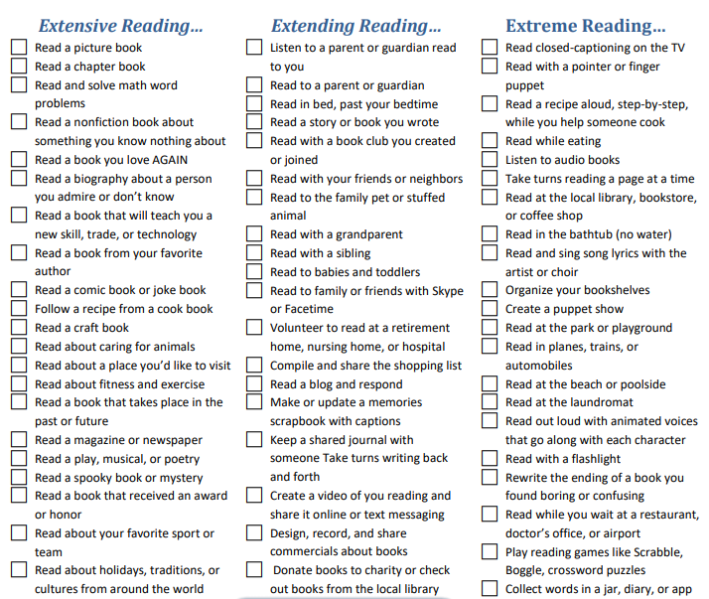

Student Name: __________________________________

Parent Signature: __________________________________ Estimated Minutes Read _______________

